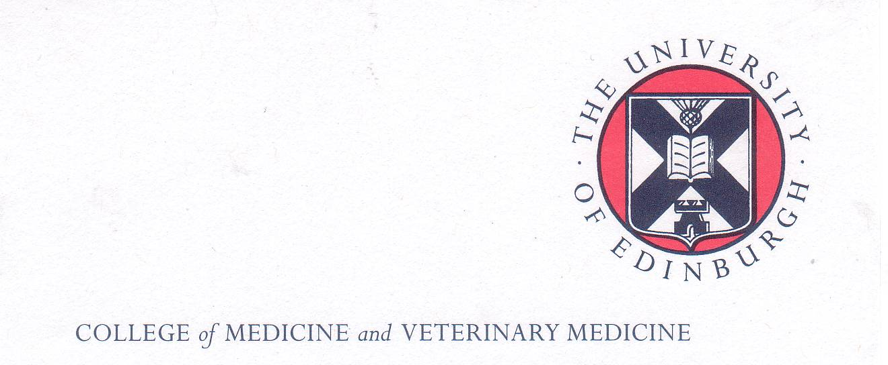Polish School of Medicine Memorial Fund Scholarships
Main Call for Applications Academic Year 2021/2022

Closing date: The scholarship deadline is 23:59 GMT 03rd June 2021. Late applications will NOT be accepted.

Introduction
The Polish School of Medicine Memorial Fund supports a thriving scholarship programme which enables successful applicants to undertake a period of further study or research at The University of Edinburgh Medical School and related institutions.

The Scholarship
For scholars undertaking research or postgraduate degree courses in Edinburgh, the award normally consists of a subsistence allowance payable for periods of 1-12 months, depending on the length of their course / research programme. It does not cover research costs or travel to and from Poland. Assistance with tuition fees is likely to be available for a limited number of successful applicants. In the case of applicants undertaking distance learning degree programmes the award will normally cover the tuition fees, subject to satisfactory progress, but no subsistence allowance is payable. Potential applicants wishing to undertake short study visits or non-degree programme related research should contact one of the coordinators below at the earliest opportunity to discuss their ideas.

Eligibility
The programme is open to Polish medical scientists
- in their early career (usually within 10 years of their medical graduation - MB ChB equivalent)
- working in Polish Medical Academies/Universities and Research Institutes
- with excellent mastery of English and
- committed to the further development of medical research expertise in Poland.

Applicants must agree to provide the Polish School of Medicine Memorial Fund Committee with a scholarship report within 1 month of completing their programme of study/ research.

The expectation and intention of the founders of the Polish School of Medicine Memorial Fund Scholarship Programme is that successful applicants should return to their units/ departments in Poland on completion of their attachment/studies, use their new found skills to further enhance and develop Polish medicine and thus foster academic links between Polish Medical Universities and Research Institutes and The University of Edinburgh.

Applications for the academic year 2020/21: Applications will be considered from eligible candidates wishing to apply for a 1 year taught Masters programme/Masters by research offered at The University of Edinburgh College of Medicine or a Masters by distance learning provided that they have the full support of their Head of Department and Polish Medical University authorities. These must be submitted via the Degree Course Scholarship Application form link.

Further information can be found at: Polish School of Medicine Memorial Fund Scholarships | The University of Edinburgh for on-line courses and at Polish School of Medicine Memorial Fund Scholarships | The University of Edinburgh in the case of Edinburgh based courses

Potential applicants may if they wish contact either of the Scholarship Coordinators listed below:

Dr Maria Długołęcka-Graham MBE  Polish School of Medicine Coordinator for The University of Edinburgh  e-mail: PSMscourse@ed.ac.uk | Prof. Blazej Męczekalski  Poznan Polish School of Medicine Coordinator  email: blazejmeczekalski@yahoo.com

Further Information for Applicants wishing to undertake short visits or research not related to a degree programme:

Applicants who wish to be considered for short visits or research not relating to a degree programme cannot apply for a scholarship via the University web-site. They must submit their applications electronically to the Polish School of Medicine Coordinator in Edinburgh by the deadline for applications The scholarship deadline is 23:59 GMT 03rd June 2021.

In addition to submitting their proposed study programme/ research programme, applicants will be required to submit the following documents:

• an up to date Curriculum Vitae in English giving sufficient information about the their achievements and experience to date so that an informed decision about their suitability can be made. A list merely giving dates, hospital names and job titles is not acceptable

• verified* copy of the diploma issued by the University or other body granting the applicant’s medical qualification.

• verified* copy of the IELTS certificate or other certificate being submitted as evidence of satisfactory mastery of the English language as required for the type of scholarship for which they wish to apply

• verified* copy of any other relevant documentation eg confirmation of their stage of specialty training, appropriate registration status and licensing with the GMC, etc.

• copy of one scientific publication in which the applicant was a main author

• letters of support written in English from the Rector of the applicant’s Medical University in Poland AND the applicant’s Head of Department in Poland

• a letter from the Head of Department in the host academic unit at the University of Edinburgh supporting the application.

* Verified by a Notary Public or other responsible person or body as a true copy of the original. In this context ‘responsible person’ means eg Dean or Associate Dean of the Medical Academy, Administrative Head of the International Office or other senior officer empowered to do this.

Please note: A separate Call for Scholarship Applications will be issued for short courses. These may be either taught face-to face in Edinburgh (when the scholarship will cover the course fee and the cost of accommodation in University of Edinburgh accommodation. Candidates who wish to arrange alternative accommodation for these short courses, do so at their own expense.

